WEEK 6
Integrative Capstone Project and Evaluation
Titanic Passenger Survival: An End-to-End Data Science Pipeline
Python • Pandas • Matplotlib • Scikit-learn
Supervised + Unsupervised Learning
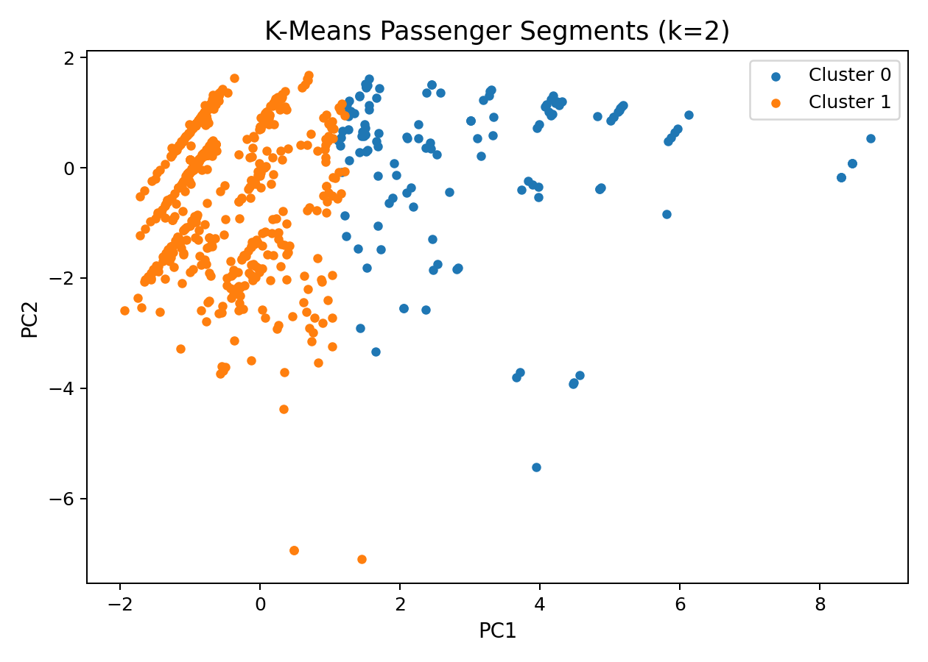
Capstone overview: passenger segments projected into PCA space.
Final Random Forest test accuracy: 81.56%

1. Executive Summary
This capstone integrates the principal data-science skills developed during the internship into one coherent pipeline. The Titanic passenger dataset is used to demonstrate data acquisition, cleaning, feature engineering, exploratory analysis, supervised prediction, unsupervised segmentation, evaluation, and communication of findings.
The supervised component uses a Random Forest classifier. On the held-out test set it achieved 81.56% accuracy, 73.68% precision, 81.16% recall, 77.24% F1, and 0.858 ROC-AUC. Five-fold stratified cross-validation on the training data provides a second view of model stability.
The unsupervised component uses K-Means on standardized passenger characteristics. Candidate values of k from 2 to 6 were evaluated with inertia and silhouette score, with k=2 producing the highest silhouette score (0.484). The clustering is descriptive and does not use the survival label as an input.

2. Problem Statement and Objectives
The central analytical question is how passenger characteristics relate to survival and whether machine-learning methods can extract useful predictive and descriptive patterns. The capstone therefore combines two complementary tasks: predicting survival for unseen records and discovering passenger segments without directly optimizing for survival.
- Design a reproducible end-to-end Python data science workflow.
- Acquire, clean, and transform a public dataset.
- Use EDA to identify important distributions and relationships.
- Build and validate a supervised classification model.
- Apply unsupervised clustering to discover descriptive segments.
- Evaluate performance using multiple metrics.
- Translate results into insights, limitations, recommendations, and future work.

3. Data Collection
The Titanic dataset is a public benchmark dataset and is also appropriate for demonstrating mixed data types, missing-value handling, feature engineering, binary classification, and clustering. For continuity across the internship, the cleaned Titanic dataset produced during Week 1 was reused as the capstone's working dataset. The project package includes that dataset so the full analysis can be reproduced from the supplied files.
- Records: 891
- Target: Survived (0 = did not survive, 1 = survived)
- Numerical inputs: Pclass, Age, SibSp, Parch, Fare, FamilySize, IsAlone, FarePerPerson
- Categorical inputs: Sex, Embarked, Title
- Engineered features: Title, FamilySize, IsAlone, FarePerPerson

4. Data Cleaning and Preprocessing
The Week 1 cleaning stage addressed missing values, inconsistencies, outliers, and feature representation. For the capstone model, preprocessing is performed through a scikit-learn pipeline so that numerical imputation and categorical encoding are learned from the training data rather than from the held-out test set.
Title was extracted from passenger names and normalized into common titles plus a Rare category. FamilySize combines SibSp and Parch with the passenger themselves. IsAlone flags passengers whose FamilySize equals one. FarePerPerson divides fare by family size, providing an additional representation of travel cost relative to party size.
df["FamilySize"] = df["SibSp"] + df["Parch"] + 1
df["IsAlone"] = (df["FamilySize"] == 1).astype(int)
df["FarePerPerson"] = df["Fare"] / df["FamilySize"].replace(0, 1)
The supervised pipeline uses median imputation for numeric features and most-frequent imputation plus one-hot encoding for categorical features. This separation is important because mixed data types should not be processed identically.

5. Exploratory Data Analysis
The overall survival rate was 38.38%. Female passengers had an observed survival rate of 74.20%, compared with 18.89% for male passengers. First-class survival was 62.96%, while third-class survival was 24.24%. These differences motivate a predictive model, but they are descriptive associations rather than causal conclusions.
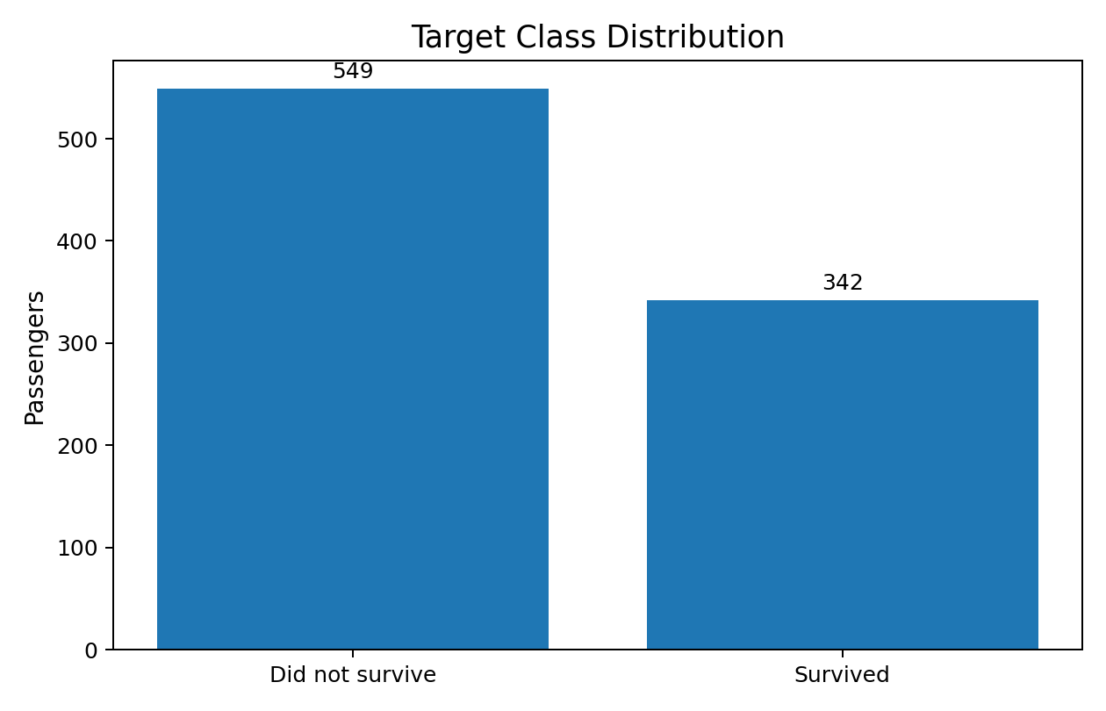
Figure 1. Target class distribution.
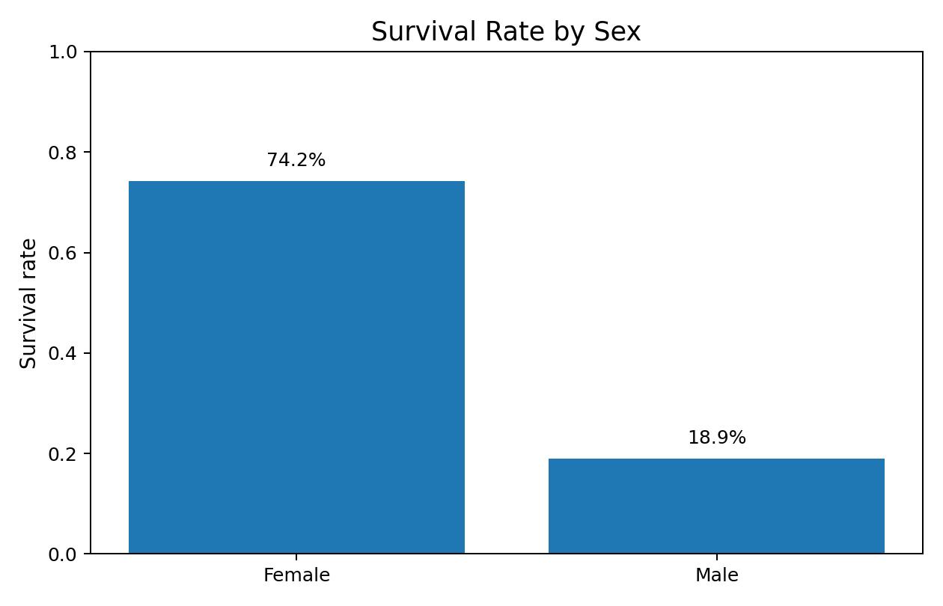
Figure 2. Survival rate by sex.
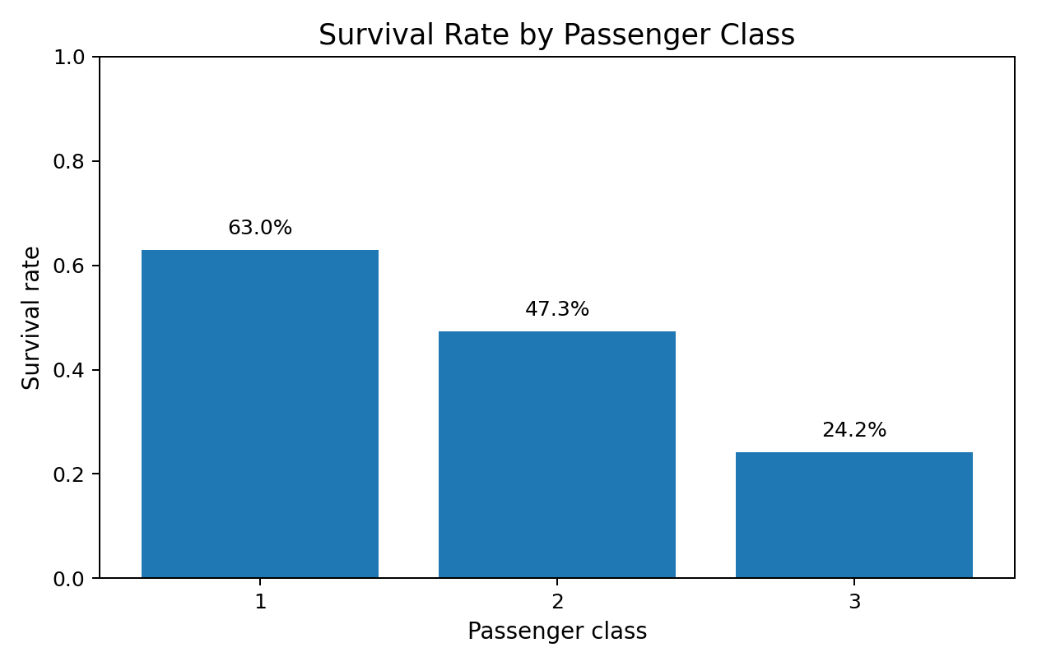
Figure 3. Survival rate by passenger class.
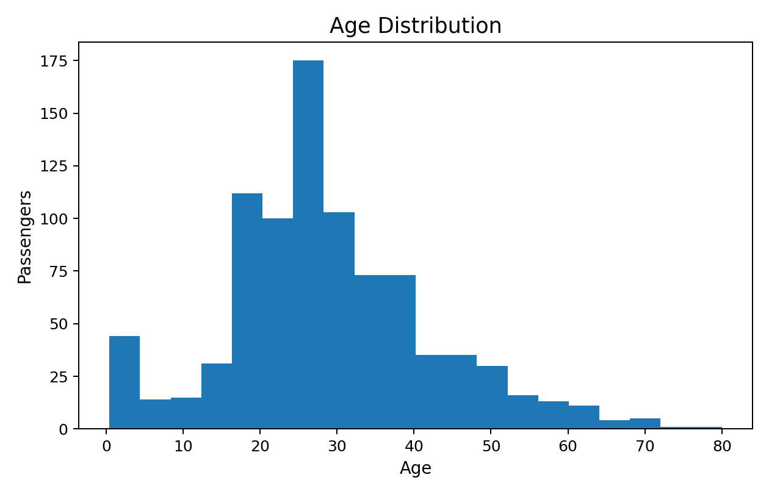
Figure 4. Passenger age distribution.
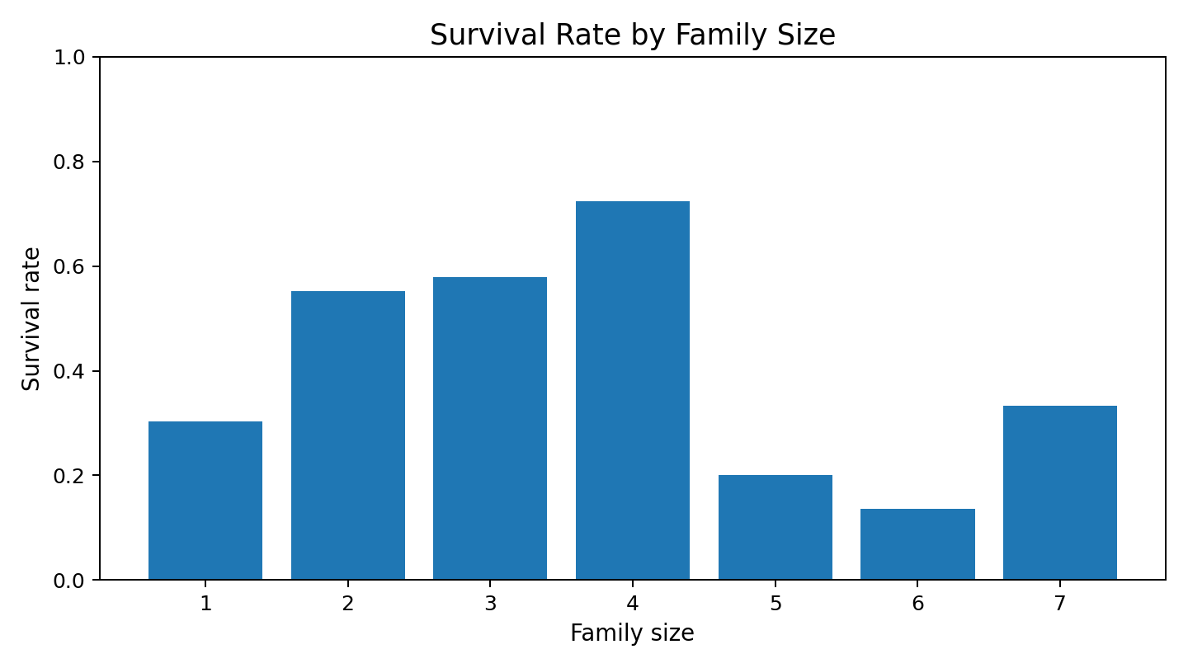
Figure 5. Survival rate by family size for groups with at least 10 records.
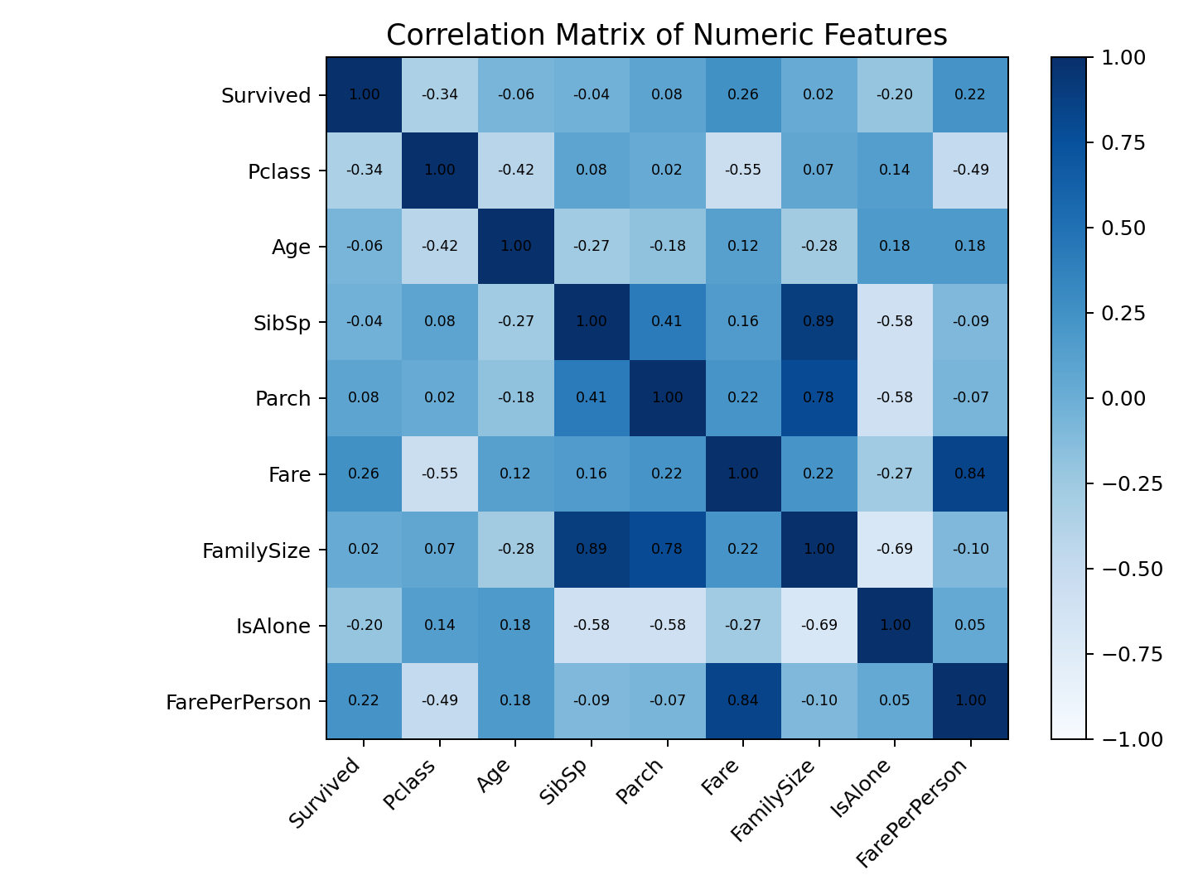
Figure 6. Correlations among numerical and engineered features.

6. Methodological Approach
The pipeline was organized so that each stage feeds the next while preserving a clear separation between exploratory analysis, model fitting, and final evaluation.
- Data acquisition and inspection
- Cleaning and feature engineering
- Exploratory data analysis
- Stratified train-test split
- Pipeline-based preprocessing
- Random Forest training
- Five-fold stratified cross-validation
- Held-out test evaluation
- K-Means clustering on standardized descriptive features
- PCA visualization and cluster profiling
- Critical interpretation and recommendations
The held-out test set is reserved for final supervised evaluation. Cross-validation is conducted on the training portion, reducing the chance that the test set influences model-development decisions.

7. Supervised Modeling

7.1 Model Selection
Random Forest was chosen because survival patterns can be non-linear and can involve interactions between passenger class, sex, age, family structure, and fare. An ensemble of decision trees can capture these interactions while requiring relatively little feature scaling and offering model-based importance measures.

7.2 Configuration
- 350 trees
- Maximum depth = 7
- Minimum samples per leaf = 3
- Balanced class weights
- Random state = 42
- Stratified 80/20 train-test split
RandomForestClassifier(n_estimators=350, max_depth=7,
min_samples_leaf=3, class_weight="balanced",
random_state=42, n_jobs=-1)

7.3 Validation
Five-fold StratifiedKFold cross-validation was performed on the training data. Accuracy, precision, recall, F1, and ROC-AUC were collected. The final model was then evaluated once on the held-out test set.

8. Supervised Evaluation
Metric | Test | 5-fold CV mean
Accuracy | 0.816 | 0.827
Precision | 0.737 | 0.784
Recall | 0.812 | 0.766
F1 | 0.772 | 0.773
ROC-AUC | 0.858 | 0.884
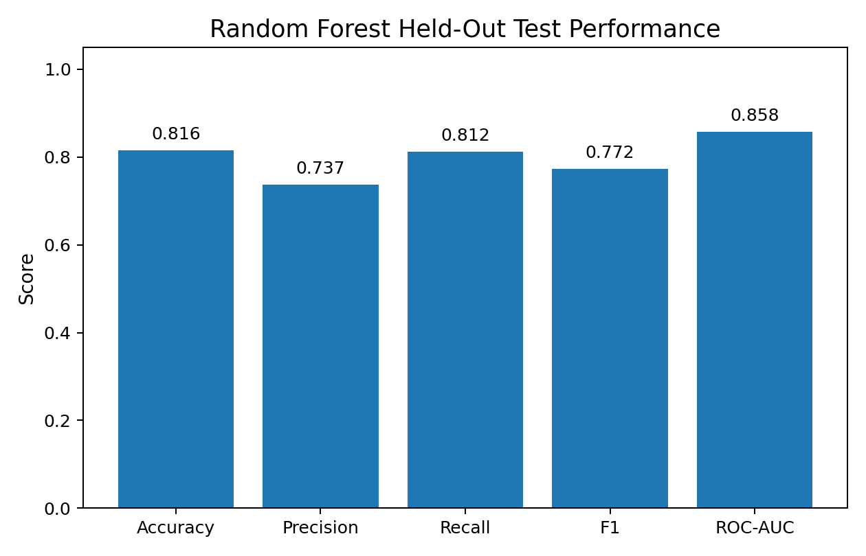
Figure 7. Held-out Random Forest performance.
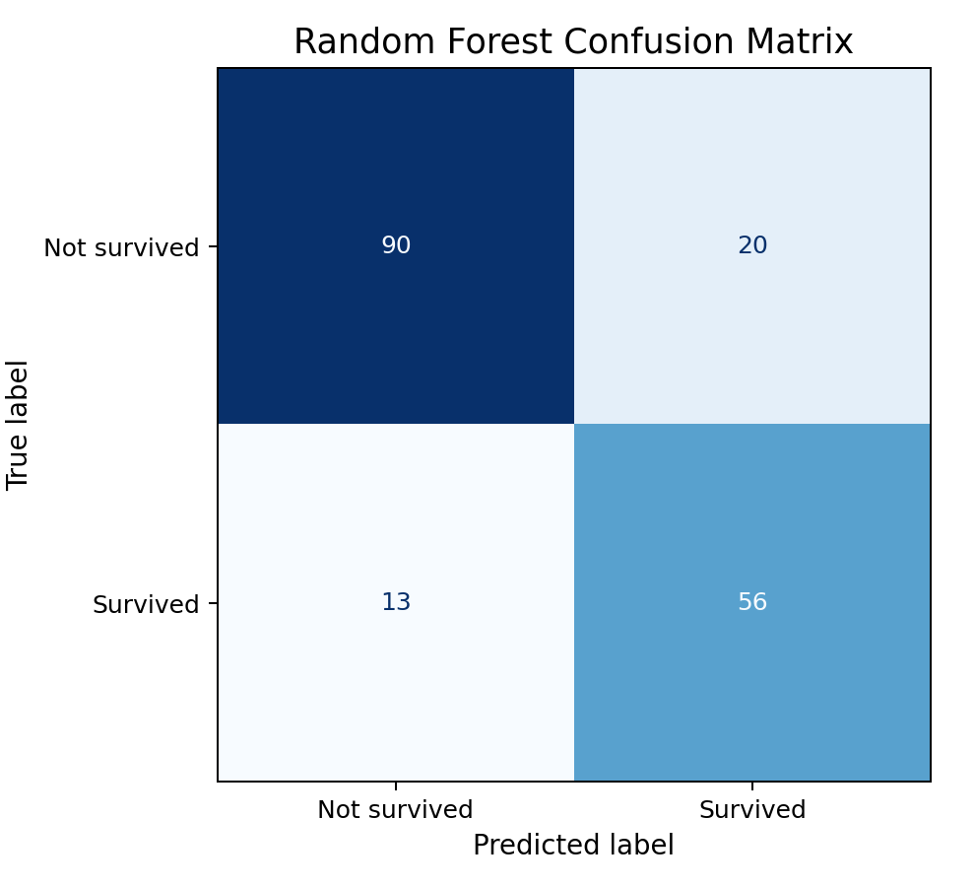
Figure 8. Random Forest confusion matrix.
The model shows strong predictive performance on this benchmark. The comparison between cross-validation means and the held-out test results provides evidence that the result is not dependent on a single training fold. However, strong performance on historical benchmark data should not be assumed to transfer automatically to other populations.

8.1 Feature Importance
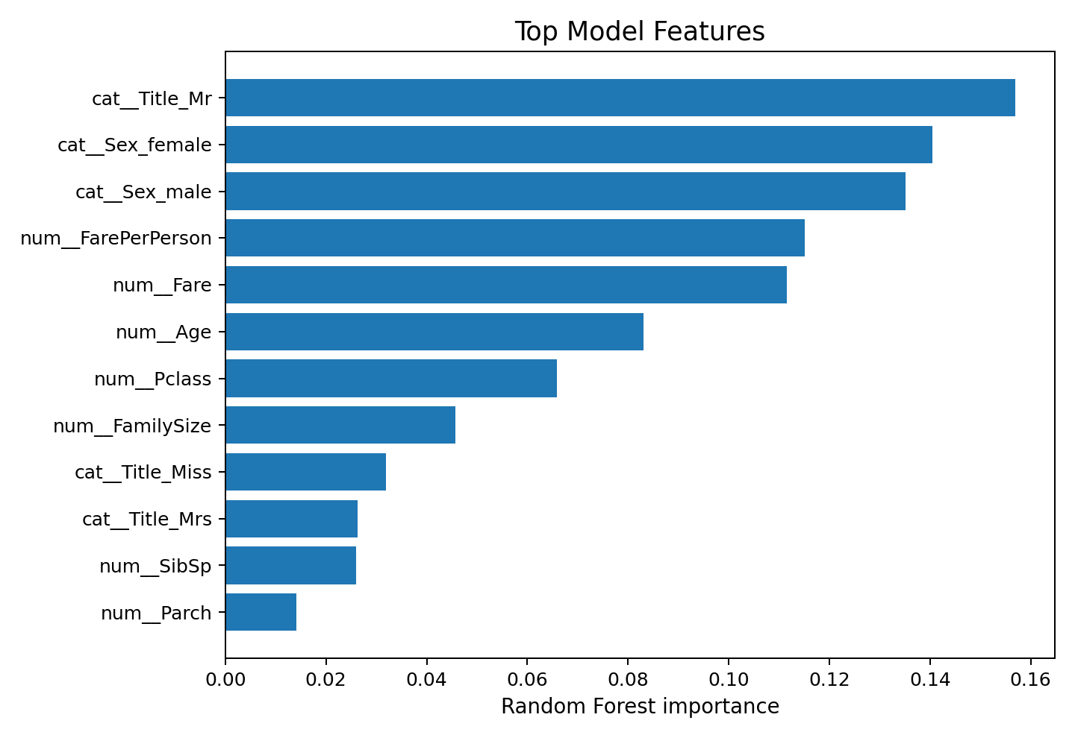
Figure 9. Top Random Forest feature-importance values.
Feature importance is useful for understanding which variables the fitted forest relied on most, but it is not causal evidence. Correlated variables can share importance, and a predictive feature may act as a proxy for another underlying factor.

9. Unsupervised Learning
K-Means was added because a capstone should demonstrate that descriptive modeling can answer a different question from prediction. The survival target was excluded from the clustering inputs. Age, Fare, FamilySize, Pclass, SibSp, and Parch were standardized before clustering.

9.1 Cluster Selection
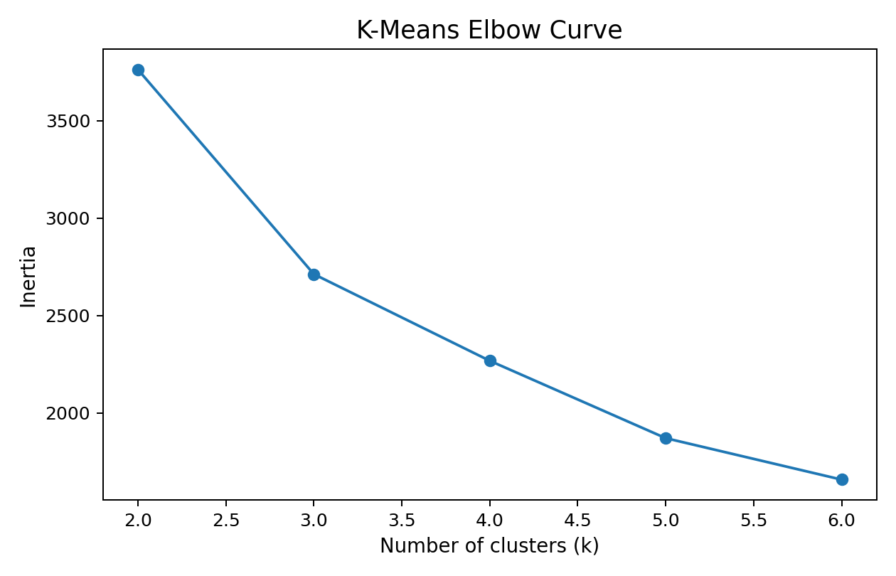
Figure 10. K-Means inertia for candidate k values.
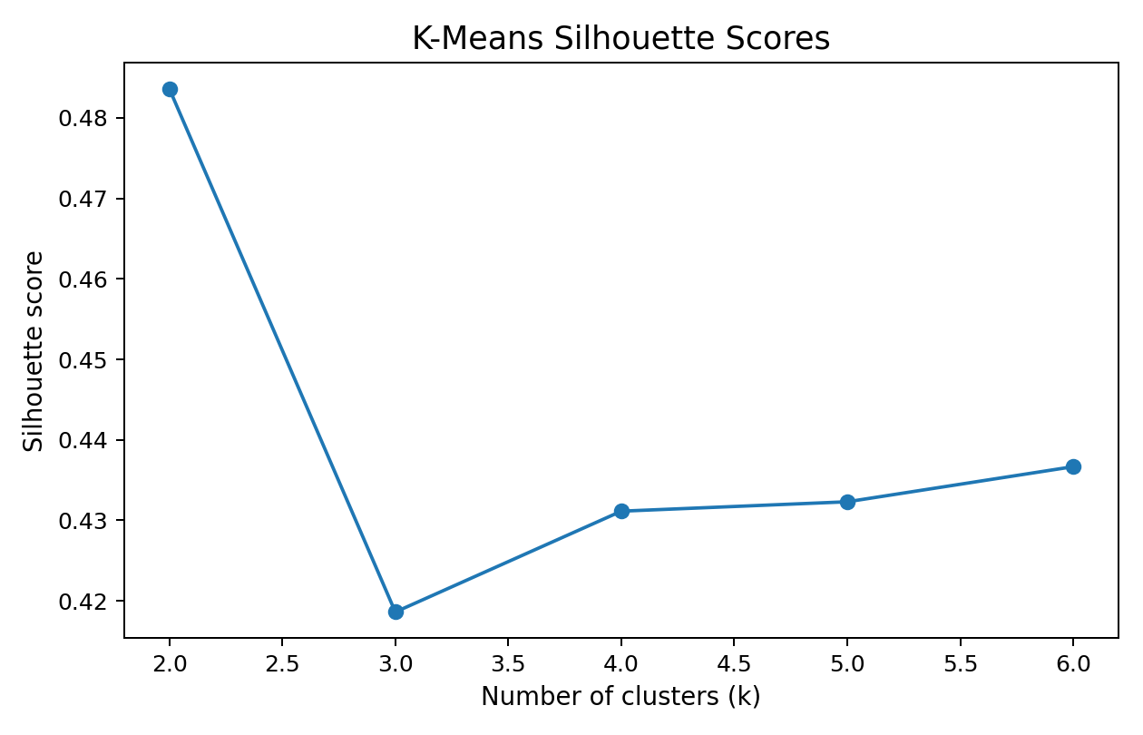
Figure 11. Silhouette scores for candidate k values.
The highest silhouette score among k=2 through k=6 occurred at k=2, with a score of 0.484. This is an analytical selection rule, not proof that the data contain exactly 2 naturally occurring groups.

9.2 Visualization

Figure 12. Passenger segments projected into two PCA dimensions.
PCA is used only for visualization. K-Means was fitted in the standardized six-dimensional feature space, so the clustering result was not created from the two-dimensional plot.

10. Integrated Insights
- Sex and passenger class show large observed differences in survival (74.2% female versus 18.9% male; 63.0% first class versus 24.2% third class).
- Family-size and fare-related features provide additional information about travel circumstances.
- The Random Forest combines several variables and their interactions rather than relying on one predictor.
- K-Means provides a descriptive segmentation of passenger characteristics without using the survival outcome.
- EDA, supervised learning, and clustering answer different analytical questions and should not be treated as interchangeable.
The combined workflow demonstrates why a complete data science project needs both statistical exploration and model-based analysis. Visual patterns can motivate modeling, while model evaluation tests whether those patterns can support prediction.

11. Challenges and Critical Reflection

11.1 Missing Values
Age and Embarked require missing-value handling. The modeling solution places imputation inside the pipeline, ensuring that preprocessing parameters are learned from the training data.

11.2 Mixed Feature Types
The dataset combines numeric and categorical variables. ColumnTransformer applies appropriate transformations to each group and then passes the combined representation to the classifier.

11.3 Overfitting and Leakage
Random Forests can overfit when trees are excessively complex. Maximum depth and minimum leaf size constrain complexity. The stronger protection against evaluation bias is the separation of training, cross-validation, and held-out testing.

11.4 Clustering Ambiguity
Unsupervised learning has no universally correct answer. Different feature choices and scaling decisions can create different segments. Silhouette score is a useful diagnostic, but practical usefulness must also be validated.

11.5 Dataset Limitations
The Titanic data are historical, relatively small, and not representative of modern populations. Results should therefore be treated as an educational demonstration of a data science pipeline, not as a modern decision-making model.

11.6 What Succeeded
The strongest success is the integration of all stages into a reproducible workflow: data preparation, EDA, supervised prediction, unsupervised segmentation, evaluation, and interpretation are connected rather than treated as isolated exercises.

12. Python Code Examples

12.1 Preprocessing and Model Pipeline
preprocessor = ColumnTransformer([
("num", SimpleImputer(strategy="median"), numeric),
("cat", Pipeline([
("imputer", SimpleImputer(strategy="most_frequent")),
("onehot", OneHotEncoder(handle_unknown="ignore"))
]), categorical)
])
model = Pipeline([
("prep", preprocessor),
("rf", RandomForestClassifier(
n_estimators=350, max_depth=7, min_samples_leaf=3,
class_weight="balanced", random_state=42))
])

12.2 Evaluation
pred = model.predict(X_test)
prob = model.predict_proba(X_test)[:, 1]
print(accuracy_score(y_test, pred))
print(roc_auc_score(y_test, prob))

12.3 K-Means
for k in range(2, 7):
km = KMeans(n_clusters=k, n_init=20, random_state=42)
labels = km.fit_predict(X_scaled)
print(k, silhouette_score(X_scaled, labels))

13. Recommendations
- Treat the Random Forest result as an educational predictive benchmark, not a production decision system.
- Use external validation or a separate dataset before claiming generalization.
- Repeat experiments with multiple random seeds to quantify variability.
- Compare Random Forest with logistic regression and gradient boosting under the same validation protocol.
- For segmentation, validate whether clusters correspond to meaningful operational or research groups before acting on them.
- Add stronger explainability and error analysis if the project is extended.

14. Future Work
- Hyperparameter tuning using training-only cross-validation.
- Probability calibration and threshold analysis.
- Repeated cross-validation and uncertainty reporting.
- Alternative clustering methods such as hierarchical clustering or DBSCAN.
- Cluster stability analysis under different feature subsets.
- External validation and domain-shift analysis.

15. Conclusion
This capstone demonstrates a complete Python data science workflow from public data through preprocessing, EDA, supervised learning, unsupervised learning, evaluation, and recommendations. The Random Forest achieved 81.56% test accuracy and 0.858 ROC-AUC, while K-Means supplied a complementary descriptive segmentation with k=2 selected by silhouette analysis.
The most important learning outcome is that data science is a pipeline rather than a single algorithm. Reliable results depend on data quality, thoughtful feature engineering, leakage-aware validation, appropriate metrics, visualization, interpretation, and honest discussion of limitations.

Appendix A. Project Files
- Week6_Integrative_Capstone_Report.docx
- capstone_pipeline.py
- titanic_cleaned.csv
- titanic_capstone_enriched.csv
- supervised_metrics.csv
- supervised_confusion_matrix.csv
- cross_validation_summary.csv
- feature_importance.csv
- cluster_selection_metrics.csv
- cluster_profiles.csv
- figures/

Appendix B. Reproducibility
The package uses Python, Pandas, NumPy, Matplotlib, and scikit-learn. Random state 42 is used for model and split reproducibility. The included dataset, code, metrics, and figures allow the project to be reviewed and extended without relying on hidden intermediate steps.

